|  |  |  |  |  |  |
| --- | --- | --- | --- | --- | --- |
| Date | 30-Nov-22 | | | Tester Name | Mayuri Patel |
| Environment | Penfax - Test | | | Login used |  |
| Operating System | Select OS | Version: | Update: | | |
| Software Used | Select Software | Version: | Update: | | |
| Select Software | Version: | Update: | | |
| Release version | 22.4.1 | | | | |
| Title |  | | | | |
| Test Type | Regression | | | | |
| Test Scenario | Set up multiple tax instructions | | | | |
|  |  | | | | |
| Expected Results |  | | | | |
| Pass/Fail | Pass | | | JIRA# | N/A |

Describe your steps with screenshots:

Search for a member to set up multiple Tax Instruction

Open that member Profile

Under Person profile🡪 Tax Instruction

Add new Tax Instruction

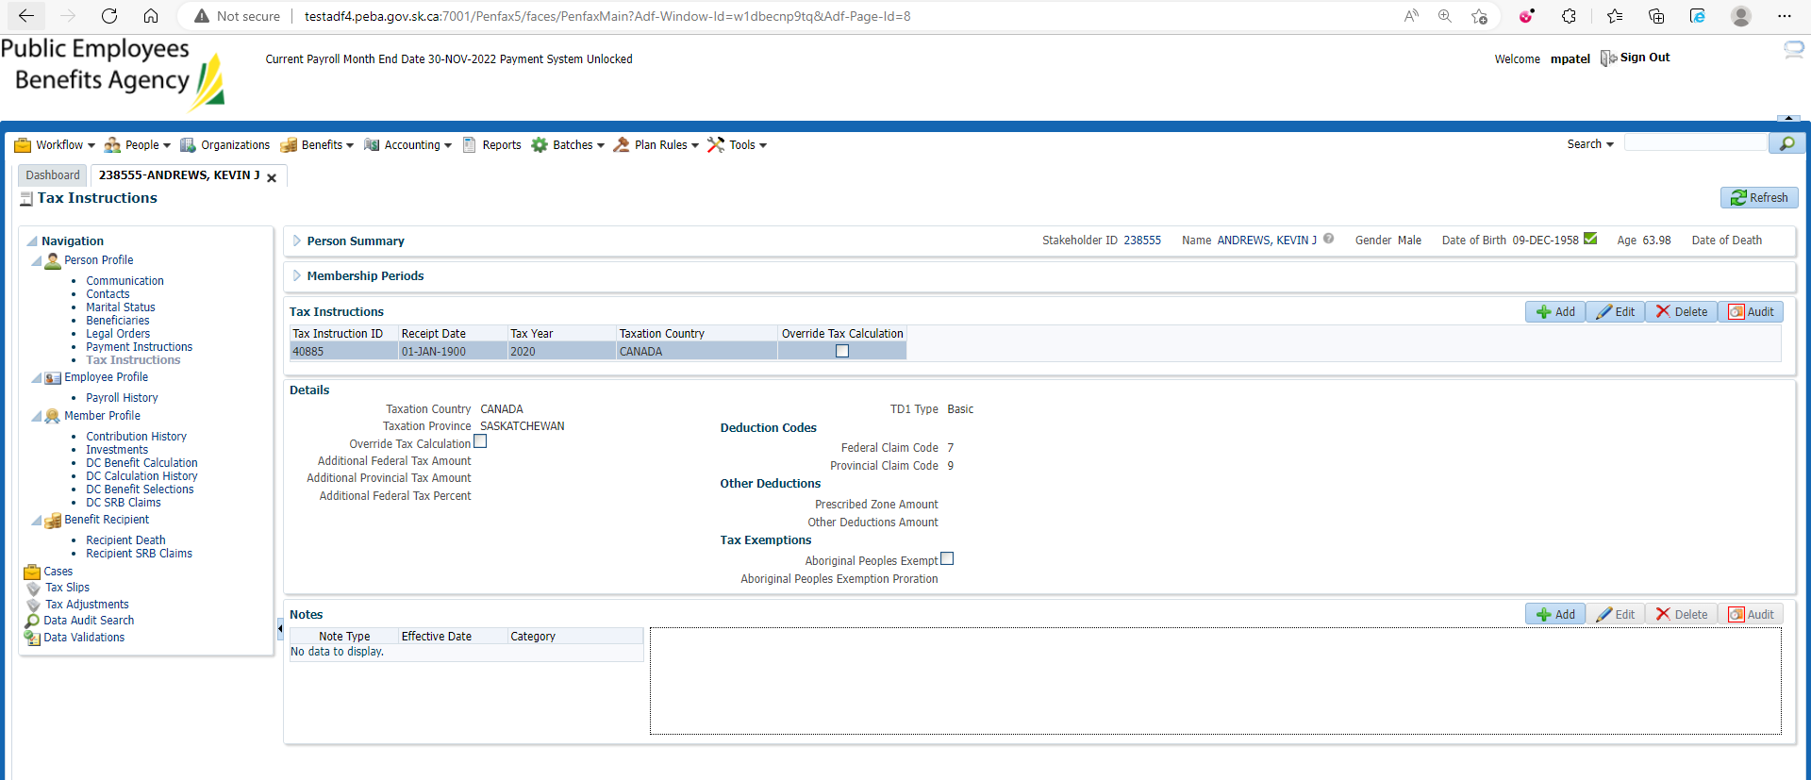

Enter mandatory details and Save

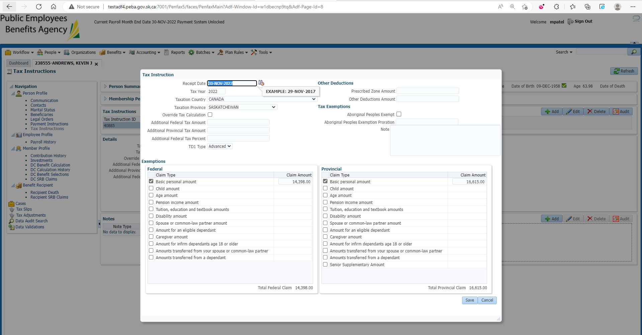

New tax Instruction is added

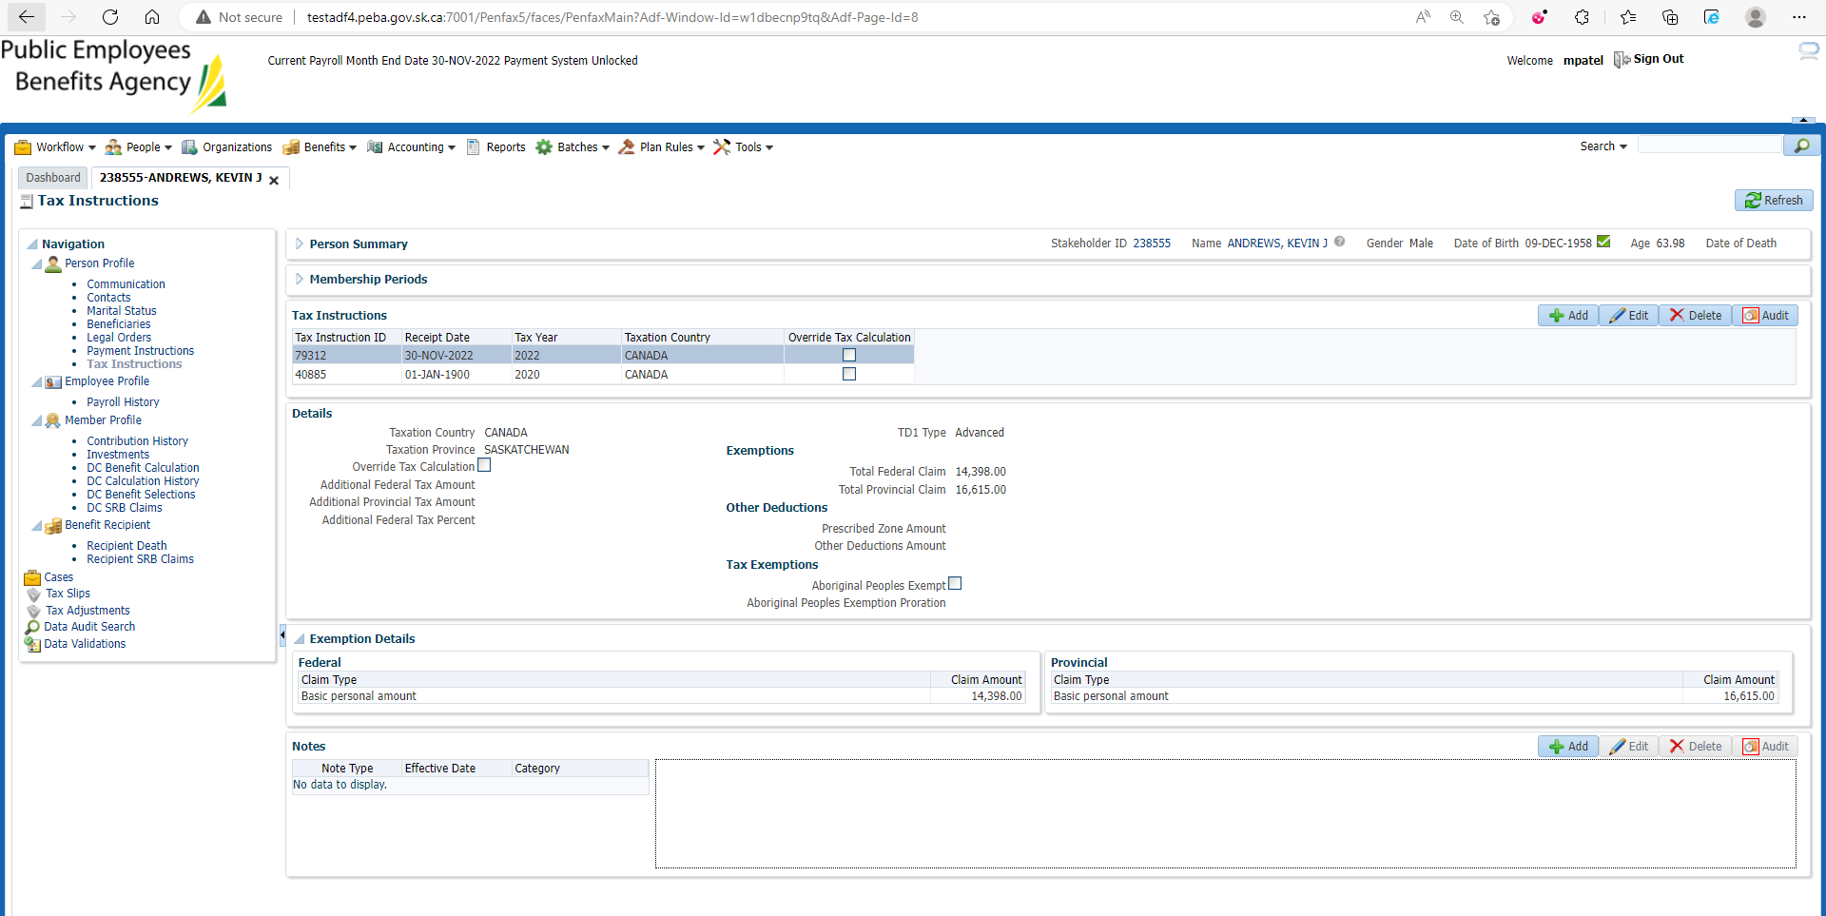

Make sure the old Tax Instruction should not be ended on Income Benefit tab under Benefit Recipient

